San Fernando Valley
Orchid Society Newsletter
March 2015
Volume 55 Issue3
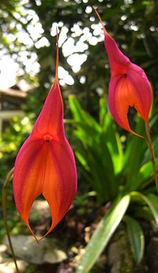
March 4, 2015
Guest Speaker: Karen Muir
Ladies in Red: Masdevallias

Karen is originally from Michigan where she began raising orchids around 1975. She was a member of the Michigan Orchid Society and held all of the offices of the Society including show chair, program chair, vice president and president. Karen became an accredited American Orchid Society Judge in 1997. In 1998, she was transferred by her Company, Lincoln Mercury, to Irvine, California and retired in January 2002. Karen also served 5 years as the American Orchid Society Chair of the Pacific South Judging Region and has traveled to Canada, Guatemala, Peru, Ecuador, Brazil, South Africa, England and Japan to attend and judge orchid shows. She has lectured on the Society circuit in the US, including the California Paphiopedilum Guild, the Slipper Alliance, NCOS (National Capital Orchid Society) Paphiopedilum Forum, two South African Paphiopedilum Conferences and the Paph Forum in London, England. Karen is now the Affiliated Societies Representative and Treasurer for the Orchid Digest. She resides in Laguna Niguel, CA. (image above Masdevallia veitichiana)

----------------------------------------------------------------------------------------------------------------------------------------------------------------------------------

A Message from our President

Thank you, Thank You, Pam Aitchison! At the February SFVOS meeting, our speaker arrived without a projector for his program. He presumed our society had one that he could use. Coming to the rescue, Pam said she had one, but it would take 40 minutes to go home and return with the projector. The Speakers, SFVOS members and guests were fine with the wait. Pam returned promptly and set up the projector. We enjoyed “Sarcochilus: Gems of Spring” with Tim Culbertson, making it an audio and visual presentation. Thank you Pam! It’s hardly enough for saving the program for all us that evening. Speaking of Sarcochilus, Tim had many characteristics of a fine speaker. He knew his subject well and he made it interesting. He projected his voice easily, without a microphone. We will be sure to invite Tim back next year for another great program.
Millie Peskay

2015 Orchid Calendar of Events
February 25 | SFVOS Board Meeting | 7pm | Home of Marcia Melcombe  10014 Andasol Ave., Northridge, CA 91325  (818) 349-8677
March 4 | SFVOS Monthly Meeting | 7pm | Guest Speaker: Karen Muir  Ladies Red: Masdevallias
March 13,14,15 | 70th Annual Santa Barbara International Orchid Show | 9am - 5pm | Earl Warren Showgrounds, Santa Barbara  $12 Gen. Adm., $10 Seniors, Students and Advance Group Sales, 3 Day Pass $20, Seniors and Students $17, Children age 12 and under - free
March 13,14,15 | Cal-Orchid Open House | 9am - 5pm | Cal-Orchid, Santa Barbara
March 13,14,15 | Gallup & Stribling Open House | 8am - 4pm | Gallup & Stribling, Carpinteria
March 13,14,15 | Hatfield Orchids Santa Barbara International Show Open House | 9am - 4pm | Hatfield Orchids, Ventura
March 14 | 40th Annual Cymbidium Congress | 8:30am-4:30pm | Adams Elementary School Auditorium, Santa Barbara
March 27 | Annual San Diego County Orchid Society Spring Show and Orchid Sale | 3pm - 7pm | Scottish Rite Event Center, San Diego
March 25 | SFVOS Board Meeting | 7pm | Home of Marcia Melcombe  10014 Andasol Ave., Northridge, CA 91325  (818) 349-8677
March 28 | Central Coast Orchid Show & Sale: "ORCHID JUBILEE: Celebrating 20 Years" | 9am - 5pm | South County Regional Center, Arroyo Grande

We need you!
Please join us in Santa Barbara on March 15th!
Our annual Orchid Auction is approaching quickly. That auction is our major fundraiser for the year and we need volunteers to help us collect orchid plants on the last day of the Santa Barbara International Orchid Show. We will meet around 3:00 pm to coordinate our efforts and then spread out to visit our sponsors and pick up the plants. Volunteers who collect and/or transport plants will be reimbursed for their entrance fees and parking. If you are able to go to the SBIOS, please help us by collecting and transporting plants back to the valley. For more information, or to volunteer, please call Pam @ (818) 406-5734. Thank you!
OUR PLANT FORUM “SHOW AND TELL”
The color seen and beauty seen in the Plant Forum is always exciting whether there are many plants or just a few. At our February SFVOS meeting, we were fortunate to see many interesting plants, including Dendrobium “Purple Splash”, Bulbophyllum L citinolabium “aka Smelly Melley”, Little Stars “Hawaii” and one not yet named. All were intermediate temperature growers and living in the Greenhouse. Thank you to Kent and Melissa Lovelady for bringing in your beautiful orchid plants to share with our society.
Our Plant Forum has been a great success as everyone enjoys learning about the orchids just as much as admiring their beauty. Each member who brings in a plant will have the opportunity to briefly discuss the history and culture of their beloved orchids. Members are not required to speak.
Please bring your blooming orchids for the plant forum. Everyone enjoys seeing what you are growing. You may enter more than one plant at a time and you will receive a free raffle ticket for each plant that you bring in to share with the group.

AOS Monthly Checklist for March and April
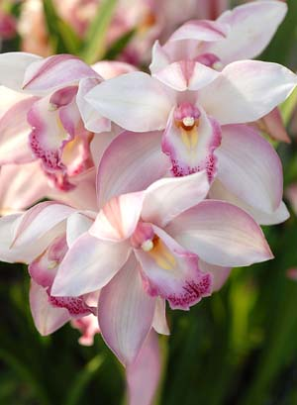Cattleya
Although March is, in many parts of the country, still a cold and blustery month, the lengthening days and warmer temperatures allowed by increased light are long-awaited harbingers of the coming change of season. Some of the best standard cattleyas of the year will be in bloom, or will be blooming soon. The last of the winter-flowering hybrids will join the earliest of the spring hybrids in a wonderful display. Be on the alert for senescing sheaths that need removal. If these yellowing sheaths are not removed, the moisture they trap can lead to bud rot. Careful removal of the sheath will allow the buds to develop, although they will need additional support. Changing light conditions can also be a problem in March and April. An exceptionally bright day, especially immediately following a rain, can lead to sunburn of the foliage if shading is not attended to properly. There can still be periods of dull days where spikes can weakened owing to the lower light. Lengthening days will mean increased metabolic rates necessitating increased water and fertilizer. The plants will indicate needs by drying more rapidly, which means more frequent watering and fertilizing.
With the passing of the season for winter bloomers, and the beginning of the season for spring bloom, it is also the time to be on the lookout for plants that will need potting after they bloom. Immediately after blooming has proven to be the best time to repot winter- and spring-flowering cattleyas. In most cases, they will be ready to grow roots, so if potted at this time, they will root right into fresh mix with little or no setback.
Cymbidium Magic Mountain photographed at Longwood
Gardens in early April. © G. Allikas
Cymbidium
Plants should be putting on a spectacular show this time of year. Adjust all staking and twist-ties and be on the lookout for aphids, slugs and snails. Give adequate water because flowering strains the plants. As new growths appear later, increase the nitrogen level in the fertilizer. Should a plant look healthy but not be blooming, try increasing the light during the next growing season. The number-one reason for no flowers is lack of light.
Dendrobium (Australian)
These hard-cane dendrobiums will be at their flowering peak now. It is not unusual to see a specimen of this type in an orchid show boasting 1,000 flowers. The secret with this group -- bred primarily from Dendrobium kingianum and Dendrobium speciosum -- is to provide ample water, fertilizer and light during the growing season.
Lycaste
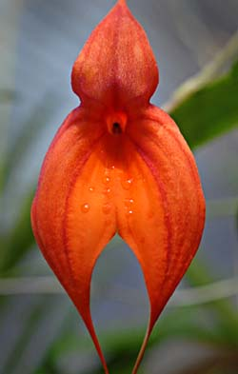This genus of superb orchids will be coming to the end of its flowering season. Soon you will see the beginning of new root growth, which is an excellent time to repot into fresh media. As new growth emerges, provide ample fertilizer and water. A sign of good culture is an increase in the size of psuedobulbs with each successive year.
Miltoniopsis
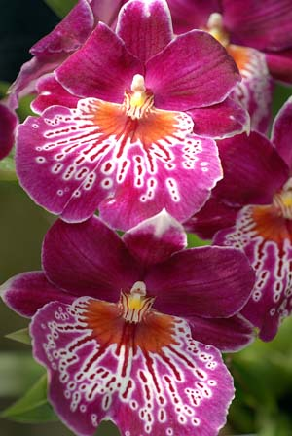This marks the beginning of the flowering season. Amazing displays of color will dazzle the grower over the next few months. Prepare your plants for optimum display by staking spikes (if needed) and cleaning off the older yellow foliage. Do not miss the wonderful fragrance as the flowers unfold..

Left: Miltoniopsis Martin Orenstein shows off a beautifulwaterfall pattern on its labellum. Photographed at Longwood Gardens in early April. Right: Masdevallia Highland Monarch 'Free Spirit' AM/AOS photographed at Parkside Orchids. Ottsville, Pennsylvania © G. llikas

March is the beginning of the season of heaviest potting for lady's-slipper orchids. However, it is a month where the volume of plants needing attention is still small. It is an excellent month to take the time to work with your paphiopedilums before the pressure of other potting prevents your doing the thorough job you should. Look at each plant: Is it clean of dead and dying foliage? Is it weed free? Does it need potting? Is it in spike? Does it have an insect problem? Cleaning and restaging your paphs is one of the most satisfying tasks of the orchid year. Cleaned and potted paphiopedilums look happy.
The summer-blooming types will be showing the first of their buds in March and April. Be on the lookout for the buds, as well as any insect pests that may have found their way into the crowns of your plants. It is especially difficult to clean mealybugs, in particular, once they have become established in the plant. Better to get to them before they get a good toehold.
Increasing light levels should give emerging spikes the strength they need to grow straight and strong. Do not be too anxious to stake the spikes, because if they are staked too soon, the flowers may develop a "nodding" stance, where the dorsal will not stand upright. If the spikes seem to develop at an angle, let them, and stake after the flower has hardened for best carriage, especially on the hybrids with fairieanum background.
Phalaenopsis
In most of the country, March is the peak blooming month for phalaenopsis. Staking needs to be carefully attended to, so that the flowers will be displayed at their best for orchid shows and judging -- even those intended for your home will look best if properly staked. One of the most decorative aspects of phalaenopsis spikes is the way they gracefully arch. If not staked properly, the spike will lack this grace and will not be as pleasing. Most growers like to have the final support just below the first flower, allowing maximum support, without sacrificing the beauty of the arching spike.
Rapid-growing spikes and open flowers place extra demands on the plant. Careful monitoring of watering and feeding will give the plants the energy they require to give their best floral display. Remember, too, that the lengthening days will also increase the frequency at which plants need water.
Beware of the invasion of sucking pests that accompany the flowering season. Flowers and spikes are favorite targets of mealybugs and scales. Be on the look out for their presence, often indicated by the appearance of sooty mold resulting from the exudate of the bugs, and treat before flowers or buds are too advanced. If flowers and buds are too far along, the chemical treatment may damage or abort them.
Pleurothallids
Members in this large and increasingly popular group will be looking their best now. If plants are not in flower, the next few months provide an excellent time to divide if needed or repot into fresh mix. Taking care of these tasks now will allow enough time for your plants to become established before the hot weather arrives.
The AOS thanks Ned Nash and James Rose for this essay.
10 THINGS TO ENJOY
AT THE 70TH ANNUAL SANTA BARBARA INTERNATIONAL ORCHID SHOW
Here are 10 things to enjoy at the crown jewel of international flower showcases the Santa Barbara International Orchid Show. For more information online, please visit: (www.sborchidshow.com).
Orchids will be coloring the scene of Earl Warren Showgrounds with the rarest, most magnificent orchid specimens from all over the world on March 13-15, 2015. The impressive exhibit — one of the oldest and largest in the United States — celebrates its 70th year as not only a display of the finest orchids, but also as a testament to Santa Barbara’s role as an historical haven for many phenomenal orchid varieties that would have otherwise disappeared into war-torn history.
1. The First Look. You will be greeted in the visitor center by a colorful overdose of orchid flowers from around the world. The first look is impressive, so take pause and enjoy the first visual experience of the 2015 theme, Celebrate with Orchids. "And it's fragrant," she notes.
2. The Fragrance. Many species of orchids attract their pollinators by their smell. The aroma of the show is floral and romantic. Many orchids have been bred to emit beautiful scents, and show-worthy orchids entries are no exception
3. The Grand Orchid Exhibits. The large displays by orchid nurseries and botanical enthusiasts are a must-see! The time intensive displays are made by artisans, gardeners, florists, and parade float professionals. This year’s theme “Celebrate with Orchids” will not disappoint.
4. Reigning Display Champion. Ventura Farms has won the Best In Show Display and top exhibit prize for the past five years, since 2000. Past Ventura Farms displays have incorporated water features, a bridge, waterfalls, and even a real Cadillac. What will Ventura Farms bring this year?
5. Orchid Selfie Photo Booth. Orchids have become the top-selling potted flower plant in America. Flower lovers of all ages will be adopting new orchids at the show. We invite them to stage a photo shoot with their new flower companions in the orchid selfie photo booth.
6. Time Lapse Video Booth. Love the dancing flowers scene from Disney’s Fantasia, 1940 animated film? Enjoy watching Vines or Instagram video clips? So do we! Now you can share your mini film making talents at the #SBorchidshowOrchid Vine Mini Film Studio.
7. 70-Years of American Orchid History. Since debuting as a premier showcase for the area’s orchid lovers and connoisseurs in 1945, the Santa Barbara International Orchid Show has played host to some of the finest orchids in the world. At its 70th anniversary event in 2015, visitors can expect to be wowed by lavish garden displays, artistic floral arrangements, and meticulously designed corsages.
8. International Orchid Show Market. For those wishing to bring home a stunning souvenir from the show, vendors offer blooming orchid plants, growing supplies, and winsome orchid-inspired art for.
9. Orchid Doctor & Classes. Enjoy educational demonstrations during the show in order to learn about best practices for growing healthy orchids. If you have an orchid that needs some TLC, visit the on site “Orchid Doctor,” expert and international consultant, Bruce Kidd, to diagnosis and prescribe an orchid fix.
10. Award-Winning Flowers from Around the World. The show brings orchid entrants from orchid specialist reaching as far as South America, Europe, and Japan. See blooms from the best and most beautiful from around the globe! Best part! You can bring them home from the Market without having to go through customs!

DETAILS:
WHERE: Earl Warren Showgrounds, 3400 Calle Real, Santa Barbara, CA 93105
WHEN: March 13th, 14th, and 15th; 9am to 5pm.

TICKETS: Individual Tickets: General: $12, Seniors (age 65 and older) and Students (with ID): $10, Children 12 and under (with adult): FREE, Tickets are also at Ticketmaster.
Winter Blooming Orchid: Oncidium “Gower Ramsay”
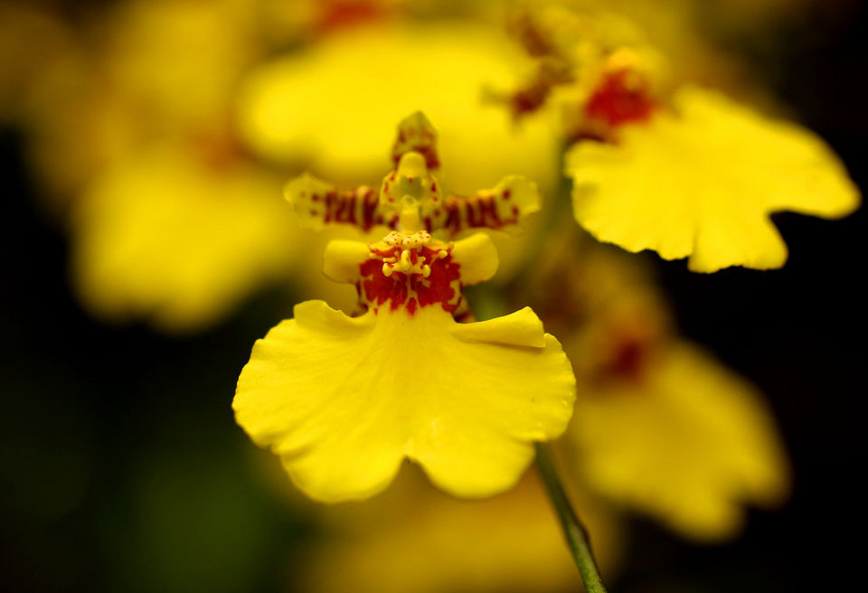

REFRESHMENTS

The Refreshments for our next meeting will be provided by members whose last names begin with the letters A through F. These members are: Pam Aitchison, Nancy Bernstein and Marie and John Feola.
Of course all members are encouraged to bring refreshments at every meeting. Healthy snacks are always appreciated by our members. Thanks for supporting your orchid society.

The San Fernando Valley Orchid Society
meets on the 1st Wednesday of the month @ 7:00pm
The Sepulveda Garden Center
16633 Magnolia Blvd. Encino, CA 91436
President & Treasurer | Millie Peskay | peskay@att.net
1st Vice President | Falguni Trieu | falutrieu@yahoo.com
2nd Vice President | Pam Aitchison | pam@aitchison.org
Recording Secretary | (open) | n/a
Corresponding Secretary | Evelyn Miterai | eviem8@att.net
Membership Secretary | Marcia Melcombe | marciafm@yahoo.com
Newsletter Editor | Pam Aitchison | pam@aitchison.org
Board of Directors/Social Media | James Jordan | jamesjordan@matthewraysalon.com

Orchids by Art
Cymbidium Orchids
and Supplies
Art Mendoza
(818) 903-0473

www.orchidsbyart.blogspot.com
Your Ad Here
In an effort to raise funds for our society we are offering advertising space in our SFVOS monthly newsletter. If you have any questions or are ready to place a business card sized ad in our publication, please contact our Newsletter Editor, Pam Aitchison by sending an email with your artwork to pam@aitchison.org. The cost is $25.00 per month, or $250.00 per year.
The Country Store
At our last meeting, Marie and John Feola donated bags of grapefruit, which turned out to be a very popular sales item. We encourage all members to bring orchids and other plants, and anything else you care to donate to our newly named “Country Store” at our monthly meetings. If you have extra fruit bag them in small quantities so we can sell each bag for a dollar. Anything brought in is considered a donation to our program, the purpose of these sales is to raise funds for our society. The funds we raise helps to pay for our speakers, insurance, the rent and the plants for our POT. Please be sure the plants are in good condition and are identified.
Thank you to John and Marie for supporting your Orchid Society.
SFVOS Newsletter
%Millie Peskay
11175 Broadview Drive
Moorpark, CA 93021

